
FURTHER EDUCATION AND TRAINING CERTIFICATE: INFORMATION TECHNOLOGY: SYSTEMS DEVELOPMENT
ID 78965 LEVEL 4 – CREDITS 165
FACILITATOR GUIDE
SAQA: 9016
REPRESENT ANALYSE AND CALCULATE SHAPE AND MOTION IN 2-AND 3-DIMENSIONAL SPACE IN DIFFERENT CONTEXTS

Facilitator Information:

Details | Please Complete this Section
Name & Surname:
Organisation:
Unit/Dept:
Facilitator Name:
Date Started:
Date of Completion:

Copyright
All rights reserved. The copyright of this document, its previous editions and any annexures thereto, is protected and expressly reserved. No part of this document may be reproduced, stored in a retrievable system, or transmitted, in any form or by any means, electronic, mechanical, photocopying, recording or otherwise without the prior permission.

Facilitator Guide Introduction
About the Facilitator Guide… | This Facilitator Guide provides a comprehensive overview of REPRESENT ANALYSE AND CALCULATE SHAPE AND MOTION IN 2-AND 3-DIMENSIONAL SPACE IN DIFFERENT CONTEXTS, and forms part of a series of Facilitator Guides that have been developed for  series of Facilitator Guides are conceptualized in modular’s format, in accordance with the Learner Guides. This guide has been designed and developed to assist you in effectively and efficiently prepare and implement your various training interventions.
Purpose | The purpose of this Facilitator Guide is to assist facilitators in delivering training sessions, related to REPRESENT ANALYSE AND CALCULATE SHAPE AND MOTION IN 2-AND 3-DIMENSIONAL SPACE IN DIFFERENT CONTEXTS. The Guide also provides information on facilitation methodologies and strategies to be adopted during training sessions.
US No | US Title |  | Level | Credit
9016 | Represent analyse and calculate shape and motion in 2-and 3-dimensional space in different contexts |  | 4 | 4
Objectives | - To understand the facilitation methodology and strategy to be adopted for this learning program  - To provide the necessary learner support and guidance during the training session
Outcomes | People credited with this unit standard are able to:  - Critique and use techniques for collecting, organising and representing data.  - Use theoretical and experimental probability to develop models, make predictions and study problems.  - Critically interrogate and use probability and statistical models in problem solving and decision making in real-world situations.  - Measure, estimate, and calculate physical quantities in practical situations relevant to the adult with increasing responsibilities in life or the workplace  - Explore analyse and critique, describe and represent, interpret and justify geometrical relationships and conjectures to solve problems in two and three dimensional geometrical situations  - Use mathematics to plan and control financial instruments including insurance and assurance, unit trusts, stock exchange dealings, options, futures and bonds  - Use simple and compound interest to make sense of and define a variety of situations including mortgage loans, hire purchase, present values, annuities and sinking funds  - Investigate various aspects of costs and revenue including marginal costs, marginal revenue and optimisation of profit  - Use mathematics to debate aspects of the national and global economy, including tax, productivity and the equitable distribution of resources.
Facilitation Methodology | The programme is very practical and aims to provide practical tools and skills for adult learners. The methodology should ensure that:  - The learning environment is physically and psychologically comfortable.  - Contact training periods are short and varied to avoid boredom.  - Learner expectations are articulated and clarified and managed by the learner and facilitator.  - The experience of participants is acknowledged and drawn on in the learning programme.  - Facilitation, rather than teaching, is used to allow participants to participate fully.  - The facilitator balances the presentation of new material, debate and discussion in such a way that the outcomes of the module are met, while ensuring that all participants are valued and are able to contribute to the learning process.  - The learning will be problem-oriented, personalized and accepting of participants’ needs for self-direction and personal responsibility.  - The module presented in a way that allows a participant to participate fully in the language of their choice.  - The facilitation process accommodates participants who may not be literate, or who are not literate in English.  The contact session uses a participatory methodology. This is appropriate for adult audiences who come with a wide range of experiences and skills. It also accommodates a broader range of learning styles. Some techniques that can be used include:
  Method | Description
  Structured learning experience | Participants engage with a complex game or activities that represent real-life situations that they may encounter in the course of their work as a Ward Committee member.
  Case study | This is a realistic story or real-life situation that has taken place, in which participants need to apply their knowledge and skills to practice how they can deal with the issues presented.
  Group work | Participants work on tasks in their groups and report their findings back to plenary.
  Lecture | The facilitator presents a short talk (maximum of 10 minutes) to introduce a new subject, to provide details, or to wrap up a session.
  Discussion | This is a free exchange of ideas or experiences on a particular topic. It may be between the facilitator and the participants or between the participants.
  Brainstorming | Participants generate a number of ideas on a particular subject or question. It may be used to gather different opinions or to find out what participants know about a particular topic.
  Role-play | Participants are asked to act out a scenario where each participant plays a particular role. A role-play may be used to illustrate how people respond in different situations.
  Panel discussion | This is a planned presentation by one or more experts. It may be followed by a discussion session or a round of questions.
Resources | - White board and/or Flipcharts  - Laptop & Data Projector (not compulsory)  - Facilitator & Learner Guide  - Learner Workbook  - Appendices (attached to learner guide)
Time | Contact/ Facilitation Days | 6 days
Time | Theory | 14 Hrs
Time | Practical | 34 Hrs
Time | Assessments | 2 Hrs
Time | Workplace Application Days | 14 Days

Facilitator’s Checklist & Training Aids
Learner support strategies:
Learners are supplied with all resources and aids as required by the program – including:
- Objects & devices such as equipment, protective clothing, and safety gear, etc.
- Learner Guides and Learner Workbook
- Visual aids, etc.

Use this checklist below during your preparation to ensure that you have all the equipment, documents and training aids for a successful session.

Preparation: | Yes | No
Qualification Knowledge – I have familiarised myself with the content of the applicable qualification
Unit Standard Knowledge – I have familiarised myself with the content of all aspects of the applicable unit standard
Content Knowledge – I have sufficient knowledge of the content to enable me to facilitate with ease
Application knowledge – I understand the programme matrix & have prepared for programme delivery accordingly
Contextualisation – I have included information which is specific to the commodity and practices related to the commodity
Ability to respond to learners background & experience – I have studied the learner demographics, age group, experience & circumstances & prepared for programme delivery accordingly
Enthusiasm & Commitment – I am passionate about my subject & have prepared my programme delivery to create a motivating environment with real commitment to success
Enterprise knowledge – I know & understand the values, ethics, vision & mission of the workplace & have prepared my programme delivery, reporting & administrative tasks accordingly.
Equipment check:
Learner guides x 1 per learner
Assessment guides x 1 per learner
Writing materials & stationary (facilitator & learner)
White board & pens
Flip chart paper
Proximal projector & screen
Laptop & programme disk
Sample Hand-outs and examples of laws and other relevant documents
Safety gear as prescribed by unit standard and applicable legislation
Documentation checklist:
Attendance Register
Course Evaluation
Learner Course Evaluation
Portfolios of evidence

Learning Program Time Frames
 | Total time allocated (hours) | Theoretical learning time allocated (hours) | Practical learning time allocated (hours) | Activities to be completed
Complete Program (including summative assessment) | 160 hours | 48 hours | 112 hours
Learner Orientation and “Ice Breaker” | 1 hour | 30 minutes | 30 minutes
Purpose, Introduction and Learner Directions | 1 hour | 30 minutes | 30 minutes
Represent analyse and calculate shape and motion in 2-and 3-dimensional space in different contexts | 40 hours | 12 hours | 28 hours
Preparation for Assessment & revision | 0.5 | - | - | -

TRAINING PROGRAM

Briefing Session: Day 1

1. Introduction to the Learning Units

 | Start with an “ice-breaker”, and eventually discuss the global outcome of the learning units with learners and emphasize the assessment process.
 | Topics | Time | Remarks
 | - Ice Breaker  - Course expectations  - Assessment Criteria  - Learner’s Responsibilities | 15 min  10 min  5 min | Please refer to Learner Guide and Assessment Guide for details.

2. Training Ground Rules

 | Discuss the training session ground rules with learners to avoid disturbance during the session
 | Topics | Time | Remarks
 | - Learning Units estimated time  - Ethical behavior  - Cellular phones – (off/silent)  - Breaks – (tea, lunch….)  - Etc… | 10 Min | Write down the training session ground rules and keep them posted in the classroom for the duration of the session.

LEARNING UNIT 1:
REPRESENT ANALYSE AND CALCULATE SHAPE AND MOTION IN 2-AND 3-DIMENSIONAL SPACE IN DIFFERENT CONTEXTS
UNIT STANDARD ID: 9016
Day 3-4: Session 3-4

 | Discuss the Learning Outcomes introduction with the learners
 | Topics | Time | Remarks
 | - Measure, estimate, and calculate physical quantities in practical situations relevant to the adult with increasing responsibilities in life or the workplace  - Explore analyse and critique, describe and represent, interpret and justify geometrical relationships and conjectures to solve problems in two and three dimensional geometrical situations | 16hrs | Ensure that all learners participate in the discussion by asking them relevant questions.
 |  | 16hrs | Ensure that learners complete the activity in their learner workbooks.

Learning Unit1
Represent analyse and calculate shape and motion in 2-and 3-dimensional space in different contexts

UNIT STANDARD NUMBER : 9016
LEVEL ON THE NQF : 4
CREDITS : 4
FIELD : Physical, Mathematical, Computer and Life Sciences
SUB FIELD : Mathematical Sciences
PURPOSE: | This unit standard is designed to provide credits towards the NUMERACY SKILLS requirements of the NQF at level 4. The essential purposes of the numeracy skills requirements are that, as the learner progresses with confidence through the levels, the learner will grow in:  - An insightful use of mathematics in the management of the needs of everyday living to become a self-managing person.  - An understanding of mathematical applications that provides insight into the learner`s present and future occupational experiences and so develop into a contributing worker.  - The ability to voice a critical sensitivity to the role of mathematics in a democratic society and so become a participating citizen.  People credited with this unit standard are able to:  - Measure, estimate, and calculate physical quantities in practical situations relevant to the adult with increasing responsibilities in life or the workplace  - Explore analyse and critique, describe and represent, interpret and justify geometrical relationships and conjectures to solve problems in two and three dimensional geometrical situations
LEARNING ASSUMED TO BE IN PLACE:
The credit value is based on the assumption that people starting to learn towards this unit standard are competent in numeracy skills and Communications at NQF level 3.

1. Polygons
The perimeter of a polygon is the distance around the “rim” or edge of the figure. Linear units such as inches, feet, meters or miles are used to measure perimeter. To find the perimeter of a polygon, add the lengths of all its sides.
1.1 Calculate the perimeter of a room that is 23 metres long and 15 metres wide. Show your calculations:
Perimeter 23+ 23+ 15+ 15= 76 metres

1.2 A rectangular swimming pool is 11,5 m long and 5 m wide. How many metres of fencing are needed to enclose the pool if you erect the fencing 2m from the edge? Show your calculations:
15.5 + 15.5 + 9 + 9= 49

1.3 In the following floor plan of a house, find the perimeter of each room and the perimeter of the entire building (Leave out the porch, bay window and optional storage):
NB.Tell learners that these plans were drawn up by the homeowner herself from blueprints on the Internet, so there is no consistency in the way the measurements are given. They will have to figure out whether she means width or length in each case by looking at the scale of the drawing.
Master bedroom | 4+4+ 6+6= 20
Master bathroom | 4+4+3,5+3,5=15
Foyer | 1,5+1,5+1,5+1,5= 6
Dining room | 4+4+4,5+4,5=17
Side entrance at kitchen | 4+4+1,5+1,5= 11
Breakfast nook and kitchen | 4+4+6,5+6,5= 21
Family room | 5,5+5,5+5+5=21
Entire house | 6+3,5+ 5+ 1,5+4+6,5+1,5+4,5+4+1,5+1,5+4+ 5,5= 49

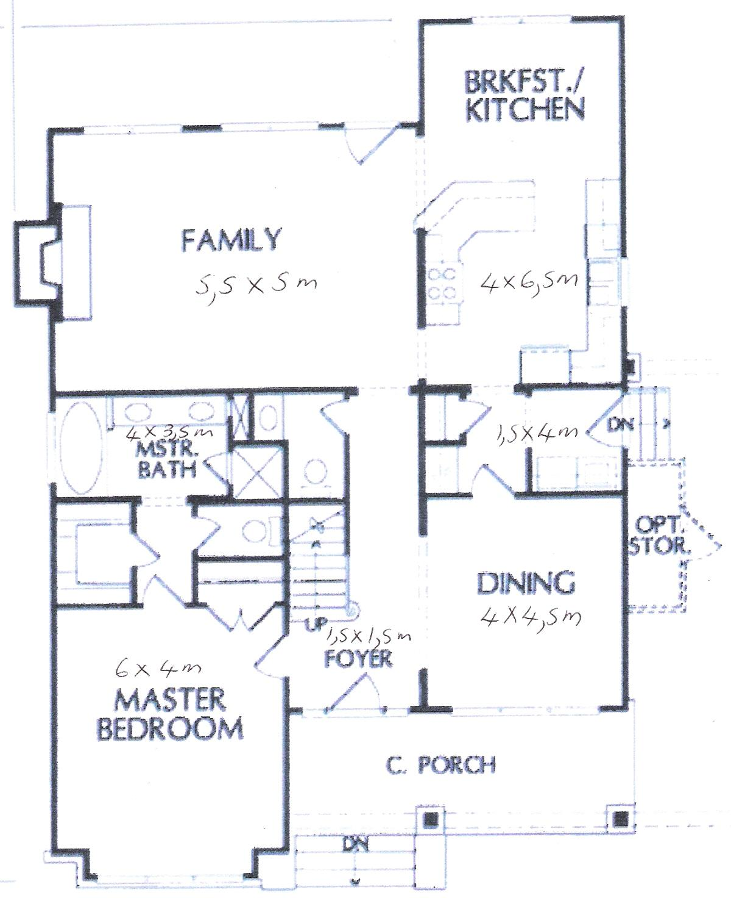

1.4 Calculate the area of each of the rooms in the house:
Master bedroom | 4x 6 = 24 m²
Master bathroom | 4x3,5 =14 m²
Foyer | 1,5x1,5 = 2,25 m²
Dining room | 4x4,5 =18 m²
Side entrance at kitchen | 4x1,5 = 6 m²
Breakfast nook and kitchen | 4x 6,5 = 26 m²
Family room | 5,5x5 = 27,5 m²

1.5 At R48.50 a square metre, what is the cost of laying a cement floor in a garage that is 6m long and 4 m wide?
48.50 x 24= R1164

1.6 Write down the formulae for calculating volume for each of the shapes shown in your Learner Guide on page 5:
Shape | Formula
Cylinder | π r² X H
Rectangular solid | L X W X H
Cube | L X W X H
Pyramid | 1/3 X B² X H

  - The rectangular swimming pool referred to in 1.2 is 11,5 m long, 5 m wide and 3m deep throughout. Calculate its volume.
11,5X5x3 = 172.5 cubic metres/ m³

2. Calculate the area of a triangle whose base is 13.9 m. and whose altitude is 7.8 m:
A= ½ b.h
A= ½ (13.9) x 7.8 =54.21m²

3. Calculate the area of parallelogram GDEF if the base is 5m and the altitude is 3,2m
F

E

3,2m

D

5m

G

Base x Altitude or A=bh: 3,2x 5 = 16 m²

4. Calculate the area of a parallelogram whose base is 17,9 cm and whose altitude is 30,25 cm in length.
Base x Altitude or A=bh: 17,9 x30,25 = 541, 475 cm² or 5,4m²

5. Find the area of a rectangle whose base is 8.4 m and whose altitude is 15.6 m in length. Show your calculation:
Base x Altitude or A=b.h
15,6 x 8,4 = 131,04 m²

6. How many cubes were needed to build the design in this figure?
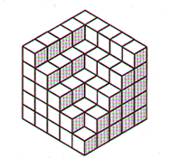

Explain several different ways of solving this problem

One is to multiply 5 by 5 by 5= 125

7. Find the circumference and area of a circle whose diameter is 14 cm:
C = π d
3.14 X 14= cm
or C= 2 π r
2(3.14) X 7= 43,96
A =π r² = 3.14 x 7²= 3.14 x 49 = 153,86 cm²

8. Can a circular tabletop with diameter 2.7 metres long fit through a doorway 2.5 metres high and 1 metre wide? Why or why not?
In the workplace/ at home: one can first try to get the tabletop through with great effort or one can apply Pythagoras and save oneself a great deal of trouble!

2,5m x²= 2,5² + 1²= 7,25m² ∴ x = 2,69

1m
However, we must bear in mind that the table top also has a certain thickness, so the answer is NO, the table top with a diameter of 2,7m cannot fit through the doorway at an angle

9. How far up on a wall of a building will a 10-meter ladder reach if the foot of the ladder is 1, 25 metres from the wall? Draw the situation and then explain your answer.
10m 10²- 1,25² = 100-1,56= √98.44 = 9.92m
1,25m
1,25m

10. What is the length of the longest pole you could put in a rectangular storage room 12 units long, 9 units wide, and 8 units high? Explain.
 Remember to pay particular attention to this activity.
17m
You must first calculate the length of the diagonal: 12²+ 9²= the square root of 225, namely 15m; this is one of the sides of the triangle we now need to use for our calculation:
∴15² + 8²= x²
∴x = square root of (225+ 64) = 17
Learners battle with this one. You will have to draw the steps for them.

11. Calculate the sum of the measures of the interior angles of the following polygons. Name the shape and then do your calculations next to the relevant shape:

Cube:
6 x 360º = 2160º


Hexagon:
4 x 180º = 720º

12. Measure surface area: These are all practical application and depend on shapes at hand
12.1 Draw a picture of your file in the space provided. Measure your file and write its dimensions down on the drawing. Calculate what size paper you would need to cover it. Leave 2cm on each side for the overlap. Let learners write down formulae
Calculate area

12.2 The training room
A. If you wanted to carpet the training room, what size carpet would you need to buy?

Calculate area of floor

B. If you wanted to tile the training room walls, and each box of tiles= 1,2m², how many boxes would you require?

Calculate area of walls

C. At a cost of R55 per box, how much would it cost to tile the training room?

Multiply answer to B with R55

13. You want to share the following recipe with your friends in Australia and Britain. Convert the recipe to their relevant units:
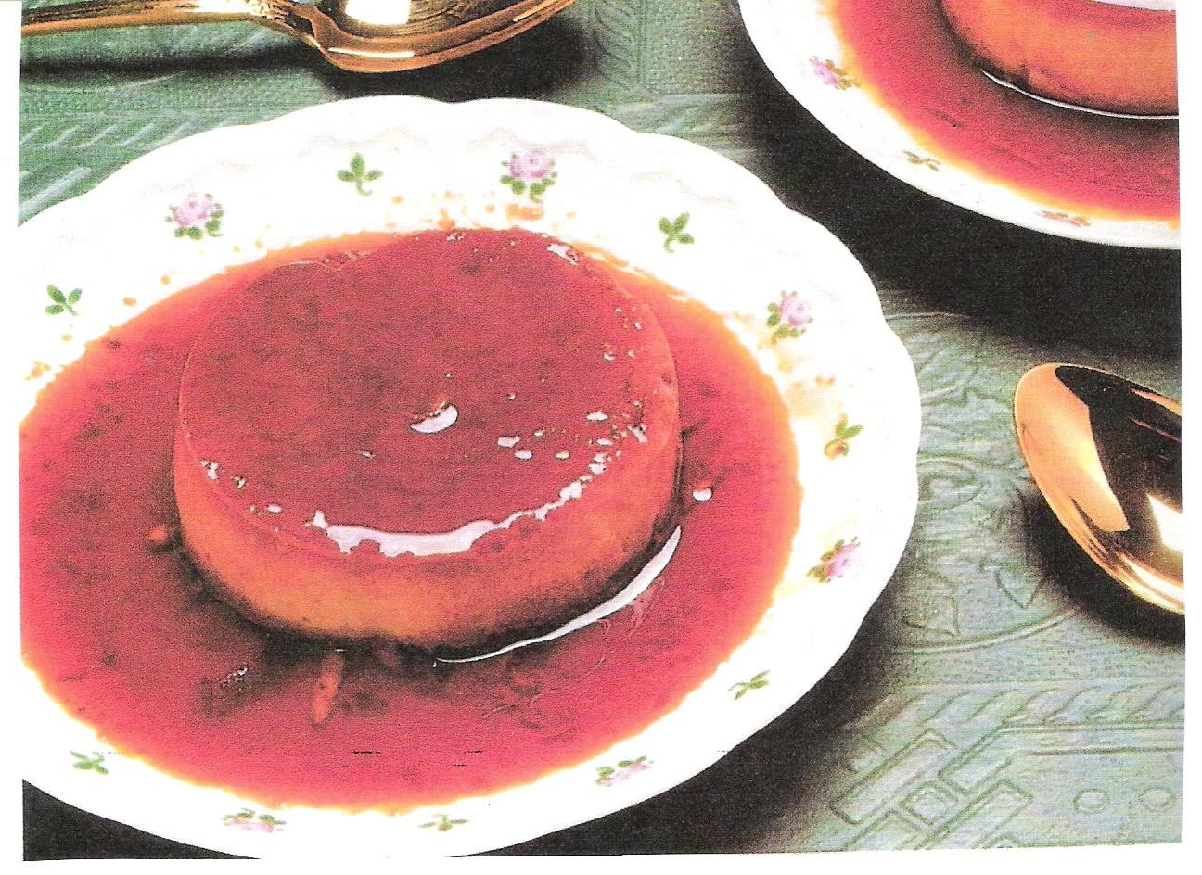
Classic Crème Caramel

940 ml milk
375 ml vanilla sugar
5 eggs
4 egg yolks
15 ml vanilla

Scald the milk and allow to cool 20 minutes. In a saucepan, melt 180 ml of sugar and cook until dark brown, stirring constantly. Take care not to scorch. Pour into a warm mould, covering the bottom and sides. Beat the eggs and egg yolks with the remaining sugar. Slowly whip in the milk and vanilla. Pour into the sugar-lined mould. Place mould in a second pan filled halfway with hot water. Bake for 45 minutes in a 160° oven. Cool, then chill. To serve, invert on to a rimmed serving platter.
SERVES 6
 | Britain (Imperial) | Australia
Milk (940 ml) | About 4 cups | About 3 cups
Vanilla sugar (375 ml) | 1 ½ cups | 1 1/8 cups
Vanilla (15 ml) | 1 tablespoon | 20ml
Oven (160°) | 325ºF | 160ºC

14. Speed and distance
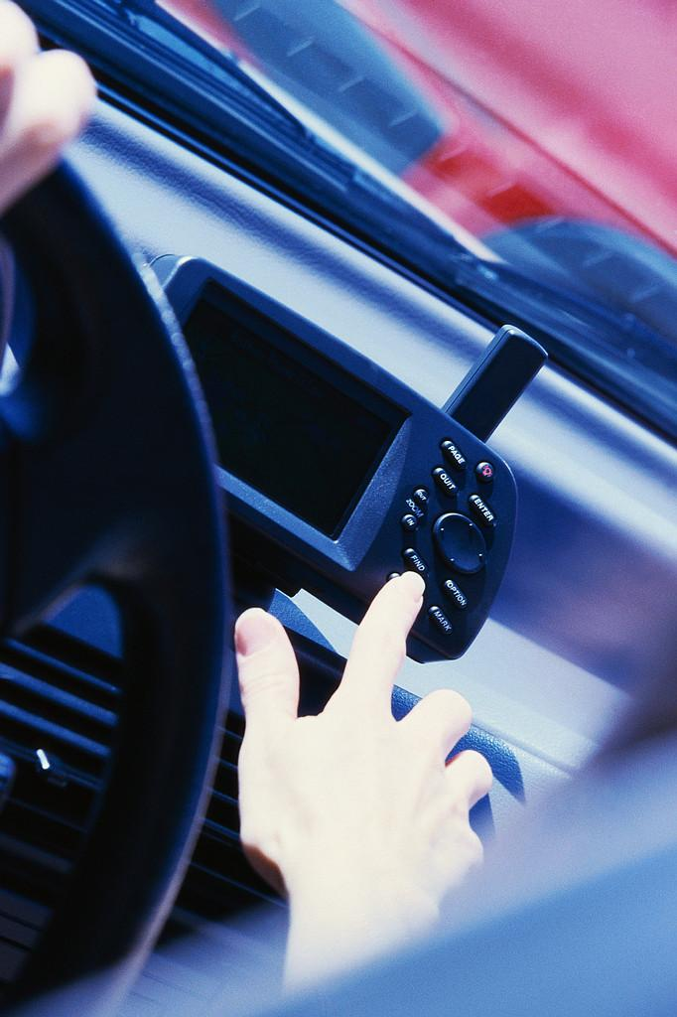

Read the 2004 Audi A6 specifications (you will recognise them from unit standard 8969) and then answer the questions that follow:
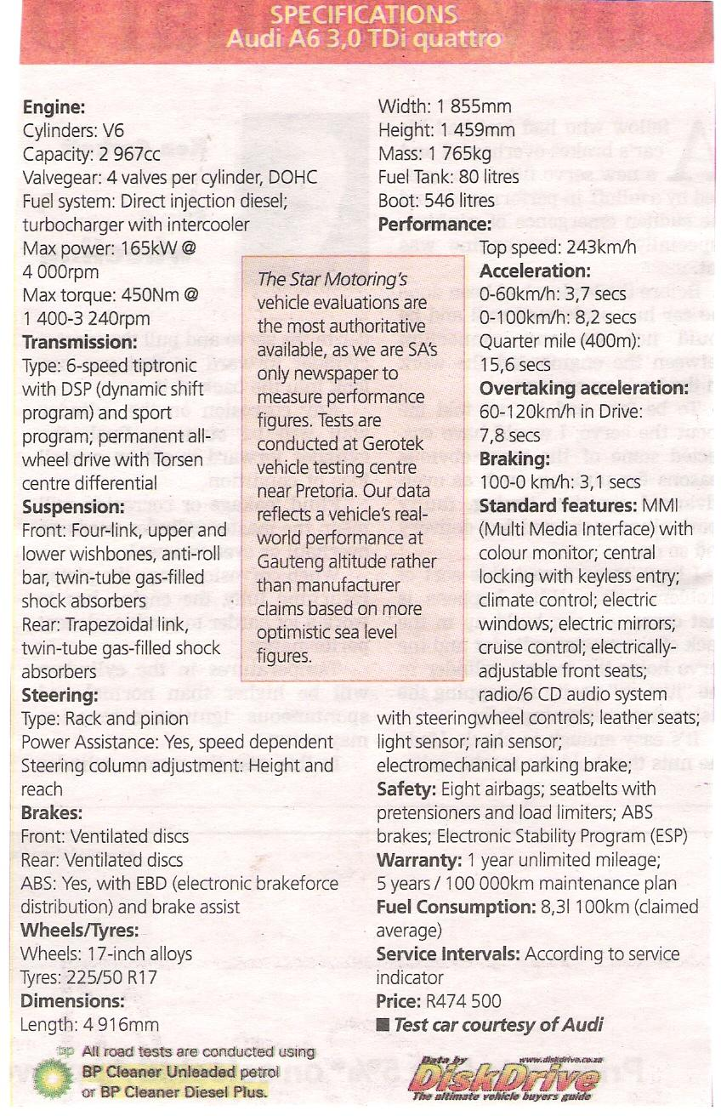

14.1 Find three examples of specifications regarding volume:
Boot

Fuel tank

Cylinders

14.2 If the diameter of the Audi’s wheels is 17 inches, calculate the circumference of the wheel.
C= Π d or 2Πr
3.14x 17= 53.38

14.3 If you travel to Durban from Johannesburg (650 km) in your new Audi A6, how much petrol will you use on average?
650⎟100 x 8.31= 54.015 or 54,02 liters

14.4 How long will it take you to get to Durban from Johannesburg at an average speed of 120 km/h?
650⎟120= 5.42 hours

14.5 Give the dimensions of the Audi A6 in metres:
Length: 4,916 m
Width: 1,855 m
Height: 1,459 m

15. The following chart reflects the profits (in millions) made by three shafts of a platinum mine over a period of a year.
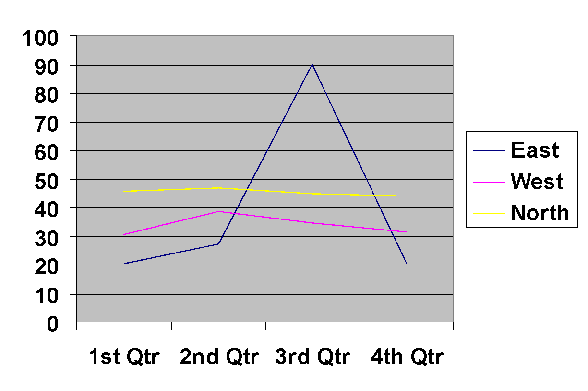
Compare the performance of the three shafts by reading the figures at the end of each quarter off the chart. Tabulate the figures. Write in the names of the shafts on the left. The answers will be approximations.
1st  E  W  N | 2nd | 3rd | Middle of 4th
24-27 | 57-60 | 50-52 | 20-22
34-37 | 35-38 | 30-32 | 30-32
44-47 | 45-47 | 41-43 | 42-44
 Remember to pay particular attention to this activity.
Discuss the performance with the learners. The median of each is:
North 45
East 38,5
West 33,5
Also remind them of trends- they will have to predict the 4th quarter results based on the trends depicted in the graph.

